|  |  |
| --- | --- |
| **Total Marks:** | **4** |
| **Obtained Marks:** |  |

**Software Construction and Development**

**Assignment # 02**

**Last date of Submission: 24th March 2024 (11:59 pm)**

**Submitted To: Ms Aniqa Shiraz**

**_____________________________________________________________________________________________________________________________________________________________________________________________________________**

**Student Name: Waseeq ur Rehman | Syed Abdul Sami Shah | Fahad Ullah**

**______________________________________________________________________________________________________________________________________________________________________________________________________________**

**Reg # : 2180245 | 2180234 | 2180209**

**______________________________________________________________________________________________________________________________________________________________________________________________________________**

**Reg. Number: 2180270 | 2180230 | 2180228**

**_____________________________________________________________________________________________________________________________________________________________________________________________________________**

***Instructions****: This is a group Assignment (continuation of Assignment 1). Clearly mention the contribution of each group member. Copied or shown assignments will be marked zero. Late submissions are not entertained in any case. Assignments should be submitted on due date and time and by one group member only.*

**Note: The soft copy must be submitted on Google Classroom.**

***Assignment:***

In continuation of your Assignment 1, you are now in the second step where you are going to construct and develop your application. Begin by creating a private Git repository and share it with all your team members, as well as with me (developeraniqa@gmail.com). Subsequently, create all the screens for the front-end part of the application and upload them to the shared Git repository. Each team member must push their task to the Git repository using SourceTree, which will display the individual contributions of the team. Ensure that all the required screens identified in Assignment 1 are included, and that they are properly linked.

For this, you must create a proper infrastructure as proposed in Assignment 1. The required artifacts for this assignment include:

1. Your project as a RAR or ZIP file.
2. A Word document containing:
   * The Git repository link.
   * Screenshots of your screens
   * Screenshots of SourceTree after pushing your task.

**The Git repository link**

**Screenshots of screens**

# Main Screen:

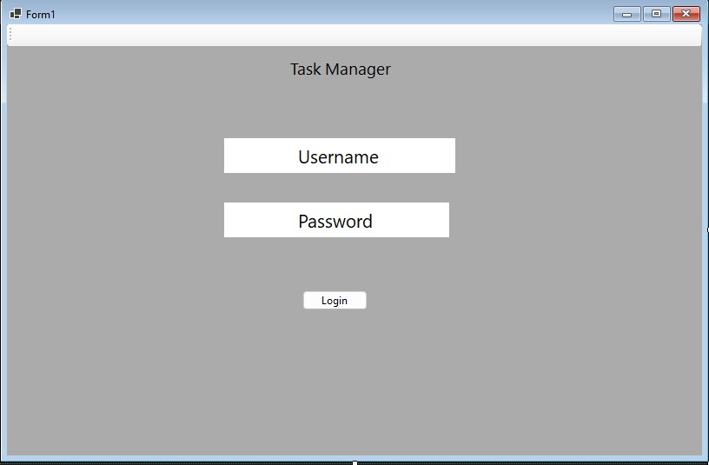

# Task Manager :

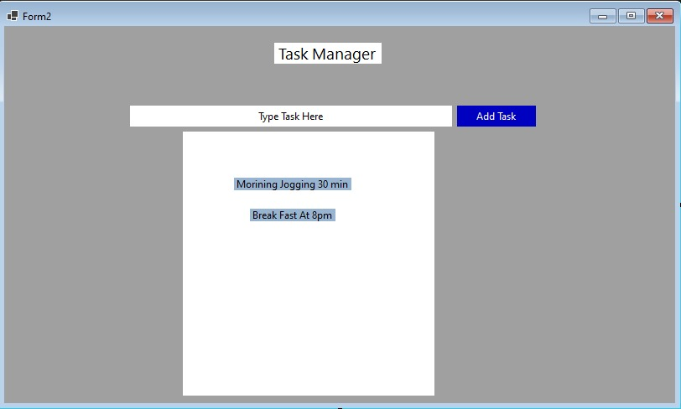

**Screenshots of SourceTree after pushing the task:**

